Natasha Lee
natasha.j.lee@northumbria.ac.uk
@N_J_Lee on twitter

Bio
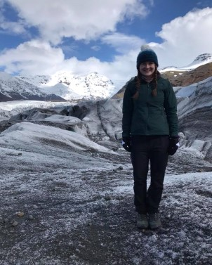
Glaciology has always been my passion within geography. My interest in controls of ice caps and the effect on the surrounding environment has developed through my research. Previously, my research has focussed on palaeo-glaciology, where I modelled the extent of the Loch Lomond Stadial in the UK and completed glacial geomorphological studies of areas to understand ice sheet behaviour. Research into the impact of ice on the surrounding environment is becoming increasingly important in the contemporary context of climate change. With average global temperatures rising it is becoming increasingly important to gain a greater and deeper understanding of glaciology.

Research Questions

The overall theme for my research for my PhD is climate change and Icelandic glaciers. This is comprised of climate change, ice dynamics and ice sheet modelling on Icelandic ice caps. I am currently assessing the role of flow parameters on ice flow of Hofsjökull ice cap, Iceland.

My current research aims to:

1. To understand controls of flow parameters on the ice flow of Hofsjökull ice
cap.
2. To estimate uncertainty in ice flow parameters and quantify the importance of
ice flow dynamics on projections on mass loss due to future climate change.
3. Investigate the behaviour of Vatnajökull and the influence of calving on
Breiðamerkurjökull.

Methodology/Techniques

I am currently using the ice flow model Úa (Gudmundsson. 2020) to develop an understanding of the basal mechanics which underly Hofsjökull ice cap, Iceland which is located in central Iceland. I am using a combination of diagnostic and inverse runs to calculate the flow parameters (basal slipperiness, basal shear stress and basal traction) which control velocity of Hofsjökull ice cap. Then, I am comparing a series of model results to a dataset of measured data from June 2012 (Minchew et al., 2016) to identify the flow parameters.

Supervisors

- Hilmar Gudmundsson, Department of Engineering and the Environment, Northumbria University, UK
- Emily Hill, Department of Engineering and the Environment, Northumbria University, UK
- Rachel Carr, School of Natural & Environmental Sciences, Newcastle University, UK

